Tittensor C.E. (VC) First School
Newsletter – October 2021

Harvest Festival
We had a great time celebrating Harvest and thanking God for the wonderful food we have to eat. Our donations were gratefully received by St. Luke’s Church Food bank. Our children love to help others.
Autumn is definitely here!
Our EYFS have been investigating Autumn. They have recognised the changes in the world around them.

Forest Schools
Every Friday we have a lesson outside where we look at the environment and nature. We are so privileged to have such fantastic school grounds.
#Hello Yellow
The school all dressed in yellow to raise awareness of children’s mental health. We raised £68 for Young Minds and learned coping strategies when we don’t feel ourselves.

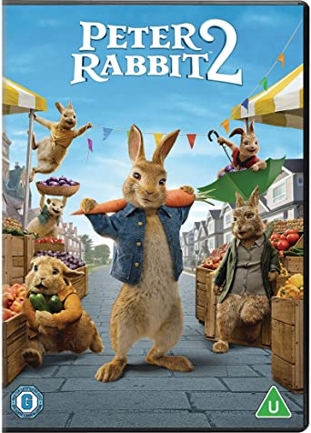

Film Night
The school had a film night, where each class watched Peter Rabbit 2 in their bubbles. Children enjoyed the delicious hotdogs as much as the film!

LMA After School Sessions
Wednesdays are fun as we have LMA Sports Coaches in after school to teach us some multi-sports. It really is good fun!

Scarecrow Parade
The children, staff and their families made scarecrows. We had a competition to see who had made the best scarecrow. Which one do you think won?

