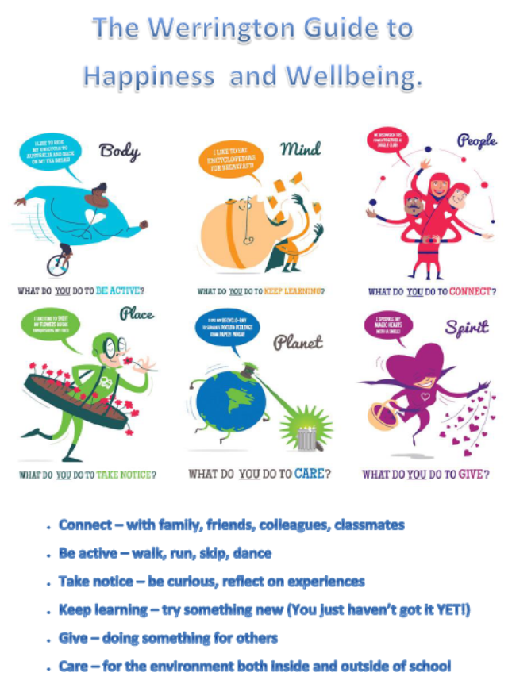

**Mental Health and Wellbeing Strategy**

**Why do we need a wellbeing and mental health strategy?**

Tittensor CE (VC) First School is an inclusive setting where mental health and wellbeing promotes school success and improvements by:

* Promoting positive mental and emotional wellbeing by providing information and support.
* Creating a shared understanding of all aspects of mental health.
* Enabling those with mental health related issues to self-disclose and seek support in a safe

confidential manner.

* Offering guidance and strategies, along with the support of Mental Health First Aiders, to support pupils and staff to be mentally healthy.
* Creating a culture to support and maintain positive mental health and wellbeing.

**What is the Mental Health and Wellbeing Strategy?**

The Mental Health and Wellbeing Strategy is a guide to define ‘how’ we are expected to support children and staff with mental health and wellbeing and ‘what’ practice we implement to support mental health and wellbeing.

The strategy details the systems in place to ensure that mental health and wellbeing is embedded into our culture to support the children and staff at Tittensor First School.

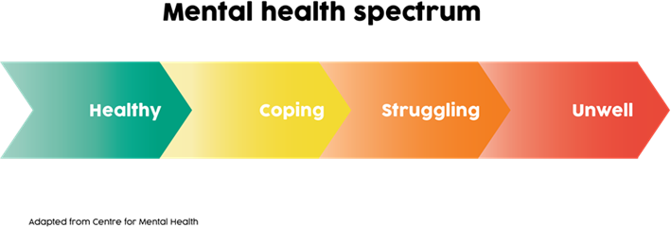

**What do we mean by mental health?**

**Mental Health is *“the emotional and spiritual resilience which enables us to enjoy life and survive***

***pain, suffering and disappointment. It is a positive sense of wellbeing and an underlying belief in our and others dignity and worth. It is influenced by our experience and our genetic inheritance.”***

**(World Health Organisation)**

Mental health affects all aspects of life and behaviour.

Like physical health, mental health is something we all have. It can range across a spectrum from healthy to unwell; it can fluctuate on a daily basis and change over time, see above spectrum.

**How does Tittensor First promote positive mental health?**

**(Prevention):**

* Promote knowledge and understanding of both internal and external support services.
* Encourage and support the whole school community to be positive in its approach to mental health wellbeing.
* Provide guidance and support to all those connected with the organisation to help them develop confidence in their ability to manage mental health and emotional wellbeing.
* Provide appropriate training and information to staff on mental health and emotional wellbeing.
* Have named Mental Health First Aiders who are the contact point at Tittensor First and a Pastoral team who are responsible for co-ordination and delivery of the school’s mental health and emotional wellbeing strategy.
* Seek to embed mental health and emotional support across the curriculum.

**How does Tittensor First support mental health?**

Addressing Needs (mechanisms to support children and staff):

* Promote a culture which supports and encourages self-disclosure.
* Use the ‘Mental Health Spectrum’ to identify children that fall into the ‘struggling’ and ‘unwell’ mental health categories and seek support from the school’s Wellbeing Lead, L Mannering.
* Provide a framework for responding appropriately to mental health wellbeing.
* Recognise that staff have the responsibility to alert others to potential and actual indicators of mental health needs and to take this action whenever necessary. For pupils, through our Wellbeing referral support system following our Safeguarding Policy and for staff, the Headteacher.
* Co-operate with other organisations involved in the delivery of mental health and emotional support services.
* Observe the principles of confidentiality and general data protection in respect of mental health and emotional wellbeing.

**What do we do if we believe a child or member of staff needs support?**

Any member of staff who is concerned about the mental health or wellbeing of a student should speak to the Mental Health Lead in the first instance. If there is a fear that the student is in danger of immediate harm then the normal child protection procedures should be followed with an immediate referral to the Designated Safeguarding Lead or Designated Assistant Safeguarding Lead. Any other Safeguarding concerns that are non-urgent should be recorded on the ‘Concerns’ sheet and shared with DSL.

**Where two cycles have been completed and there are still unmet needs refer to School Cousellor, CAMHS, Younger Minds, Dove or other appropriate agencies.**

**Concern raised by parent, child or member of staff –** see ‘The Tittensor Wellbeing Test’

**A Wellbeing Referral Form completed - forward to L Mannering**

**The Tittensor Wellbeing Test:**

This very simple test has been developed to aid staff in determining if a pupil may be in need of a wellbeing-style structured conversation. It is scored as follows:

|  |  |  |  |
| --- | --- | --- | --- |
| **Score Indicator** | 0 | 1 | 2 |
| **Smiling** | Looks ‘glum’ | Occasionally smiles | Smiles readily |
| **Talking with peers** | Sits alone and talks to no one | Will talk when prompted | Talks readily with peers |
| **Appearance** | ‘Scruffy’ | Generally well-kempt | Cares about appearance |
| **Talking with adults** | Barely engages with adults | Will talk with adult when prompted | Talks readily with adults |
| **Attendance and effort** | A persistent absentee, frequently late.  Little or no effort in lessons/activities | Attendance rate of 90% - 94%, sometimes late.  Little/below average effort in lessons/activities | Attendance 95% or better, rarely late.  Good effort in lessons/activities |

A pupil who scores a 7 or higher is considered to have good emotional wellbeing, while a score of 3 or lower may indicate the need for a structured conversation with our Wellbeing Lead, L. Mannering.

**Supporting staff to positive mental health and wellbeing**

The Governing Body’s ‘duty of care’ towards employees, legislation and case law, require them to manage and safeguard the physical and psychological well-being of the school’s employees.

We need to have a clear understanding of the causes of absence in order to formulate strategies that address non-attendance (sickness absence). The main causes of absence can be viewed as four distinct areas:

***Well teachers teach well***

The Governing Body will continue to promote and work towards performance improvement and efficiency, getting the very best from our staff, retaining and attracting the people who are best skilled and well-motivated.

Wellbeing in the workplace is relevant to all employees and everyone can contribute to improved wellbeing at work. Addressing workplace wellbeing can help strengthen the positive, protective factors of employment, reduce the risk factors for mental ill health and improve general health.

***“In case of emergency, air masks will drop from the ceiling. If you are travelling with a child, please put on your own mask before helping the child.”***

To fulfil this commitment the Governing Body and Senior Leadership Team will:

* Make health and wellbeing a core priority. Value the strategic importance and benefits of a healthy workplace. We will encourage a consistent, positive approach to all staff health and wellbeing.
* Make clear the link between employees' health and wellbeing and improved performance.
* Ensure all leaders at Tittensor, including Governors, are committed to the health and wellbeing of staff and act as good role models.
* Make communication clear to ensure that staff have realistic expectations of what's possible, practical and affordable.
* Be aware that a return to work from sickness does not necessarily indicate that an employee's health and wellbeing has improved. Return to work interview takes into account that aggressive return to work procedures can encourage presenteeism to the detriment of our school.
* Recruit staff who have the positive leadership traits associated with improved staff health and wellbeing. These traits include being open and approachable and encouraging new ideas.
* Ensure health and wellbeing policies are included in any induction, training and development programmes for new staff.
* Promote ‘Think well’ and ‘Teacherline’ as valuable mental health resources to staff.
* Have a proactive and visible commitment to health and safety and its role in improving the health and wellbeing of staff, that is, view health and safety as part of the culture of a caring and supportive employer – not only a statutory requirement.
* Create a supportive environment that enables employees to be proactive when and if possible to protect and enhance their own health and wellbeing.
* Seek to identify potential circumstances that may affect the wellbeing of staff and conduct risk assessments.
* Increase awareness and understanding of how to promote wellbeing at work and the avoidance of absence.
* Ensure advice and guidance is available to leaders in dealing with wellbeing concerns of staff.
* Ensure that there is a culture where there is no expectation that staff communicate about work outside of normal working hours (except in an emergency, e.g. child protection issues).
* Ensure that all staff take part in a supportive performance management process.
* Conduct an annual (anonymous) staff survey in order to collate information from all staff groups, which will inform future strategies to support the health and wellbeing of staff.

Where possible, staff are supported with their work/life balance and wellbeing outside the school. Examples of this could include providing staff with paid leave for both special events and celebrations, and time off to deal with family problems.

All staff are encouraged to take a responsible approach to health and wellbeing issues, including adopting a robust self-management to their own health.

**Wellbeing Audit**

The protection and fostering of staff wellbeing is increasingly embedded in our management methods and systems. A staff wellbeing audit and a workload audit will be carried out during Summer 2021 to assess and audit current level of wellbeing, so that an Action Plan can be developed - decide where we want to be and then work out how we are going to get there.