Tittensor CE (VC) First School – Knowledge Rich Project 2022-24

 |  |  | Term 1 |  |  |  |  |  |  | Term 2 |  |  |  |  |  |  | Term 3
N/R Cycle A | Main project |  |  | Me and My Community |  |  |  | Starry Night |  | 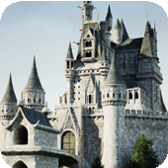 | Once Upon a Time |  |  |  | Marvellous  Machines |  | 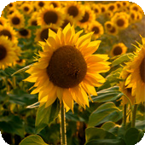 | Sunshine and Sunflowers |  |  | Big Wide World
 | Mini project |  | Exploring Autumn |  |  |  | Winter Wonderland |  |  | Sparkle and Shine |  |  |  | Puppets and Pop Ups Tittensor |  |  | Shadows and Reflections |  |  | Splash!
N/R Cycle B | Main project |  | 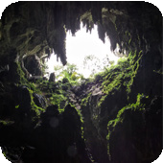 | Let’s Explore |  |  | 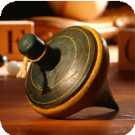 | Long Ago |  | 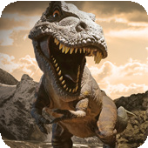 | Dangerous Dinosaurs |  |  | 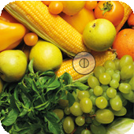 | Ready Steady Grow |  | 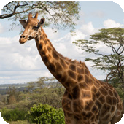 | Animal Safari |  | 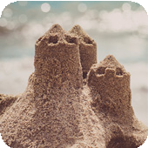 | On the Beach
 | Mini project |  | Build It Up |  |  |  | Stories and Rhymes |  |  | Puddles and Rainbows |  |  |  | Signs of Spring |  |  | Creep, Crawl and Wriggle |  |  | Move It |  | Moving On
Y1/2 Cycle A | Main project |  |  |  |  | 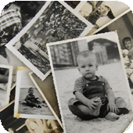 | Childhood  History |  |  |  |  |  |  | Bright Lights, Big City  Geography |  |  |  |  | 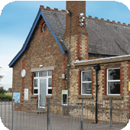 | School Days  History
 | English pack genres |  | Autobiographies |  |  | Non-chronological reports |  | Riddles |  | Information posters |  |  | Directions |  | Narratives |  | List poems |  | Diaries |  | Letters
 | Book study |  | Wilfrid Gordon McDonald Partridge |  |  |  |  |  |  | Topsy and Tim Visit London |  |  |  |  |  |  | Whiffy Wilson: The Wolf who wouldn’t go to school
 | Mini projects | Science* | Everyday materials |  |  |  | Humans |  |  | Seasonal changes |  |  |  |  |  |  | Plants |  |  | Animals
 |  | A&D | Mix It (Y1) |  |  |  | Funny Faces and Fabulous Features |  |  | Rain and Sunrays |  |  |  |  |  |  | Street View
 |  | D&T | Shade and Shelter |  |  |  |  |  |  | Taxi! |  |  |  |  |  |  | Chop, Slice and Mash
 |  | Geography | Our Wonderful World |  |  |  |  |  |  | Geography covered in the main project |  |  |  |  |  |  | Geography revision and retrieval practice
 |  | Maths | Autumn White Rose Maths |  |  |  |  |  |  | Spring White Rose Maths |  |  |  |  |  |  | Summer White Rose Maths
Y1/2 Cycle B | Main project |  |  |  |  | 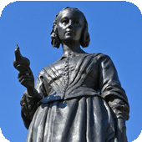 | Movers and Shakers  History |  |  |  |  |  | 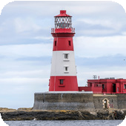 | Coastline  Geography |  |  |  |  | 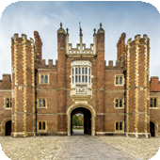 | Magnificent Monarchs  History
 | English pack genres |  | Biographies |  | Newspaper reports |  | Posters |  | Speeches | Descriptions |  | Adventure narratives |  | Non-chronological reports |  | Persuasive writing | Information leaflets |  | Kennings poems |  | Comic strips
 | Book study |  | Rosa Parks |  |  |  |  |  |  | Katie Morag and the New Pier |  |  |  |  |  |  | Queen Victoria’s Bathing Machine
 | Mini projects | Science* | Humans |  |  |  | Living things and their habitats |  |  | Uses of everyday materials |  |  |  | Plants |  |  | Animals
 |  | A&D | Mix It (Y2) |  |  |  | Still Life |  |  | Flower Head |  |  |  |  |  |  | Portraits and Poses
 |  | D&T | Remarkable Recipes |  |  |  |  |  |  | Beach Hut |  |  |  |  |  |  | Cut, Stitch and Join |  |  | Push and Pull
 |  | Geography | Let’s Explore the World |  |  |  |  |  |  | Geography covered in the main project |  |  |  |  |  |  | Geography revision and retrieval practice
 |  | Maths | Autumn White Rose Maths |  |  |  |  |  |  | Spring White Rose Maths |  |  |  |  |  |  | Summer White Rose Maths

 |  |  | Term 1 |  |  |  | Term 2 |  |  |  | Term 3
Y3/4 Cycle A | Main project |  |  | 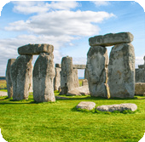 | Through the Ages  History |  |  | 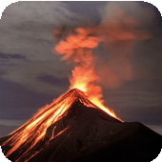 | Rocks, Relics and Rumbles  Geography |  |  |  | 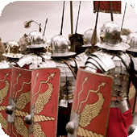 | Emperors and Empires  History
 | English pack genres |  | Narratives | Instructions | Cinquains | Chronological reports | Non-chronological reports | Shape poems | Newspaper reports | Diaries | Biographies | Letters |  | Myths |  | Poems
 | Novel study |  | Stig of the Dump |  |  |  | The Firework-Maker’s Daughter |  |  |  | Roman Tales: The Goose Guards
 | Mini projects | Science* | Animals, including humans |  |  |  | Forces and magnets |  |  |  | Plants |  |  | Light
 |  | A&D | Contrast and Complement (Y3) |  | Prehistoric Pots |  | Ammonite |  | People and Places |  | Beautiful Botanicals |  |  | Mosaic Masters
 |  | D&T | Cook Well, Eatwell |  |  |  | Making It Move |  |  |  | Greenhouse
 |  | Geography | One Planet, Our World |  |  |  | Geography covered in the main project |  |  |  | Geography revision and retrieval practice
 |  | Maths | Autumn White Rose Maths |  |  |  | Spring White Rose Maths |  |  |  | Summer White Rose Maths
Y3/4 Cycle B | Main project |  |  | 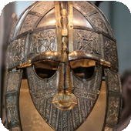 | Invasion  History |  |  | 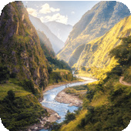 | Misty Mountain, Winding River  Geography |  |  |  | 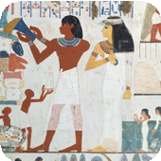 | Ancient Civilisations  History
 | English pack genres |  | Anglo-Saxon poems | Playscripts | Norse myths | Non-chronological reports | Diaries | Leaflets | Explanations | Narrative poems | Free verse poems |  | Instructions |  | Stories from other cultures
 | Novel study |  | The Saga of Erik the Viking |  |  |  | King of the Cloud Forests |  |  |  | Secrets of a Sun King
 | Mini projects | Science* | Animals, including humans |  | Sound |  | States of matter |  | Living things and their habitats |  | Electricity
 |  | A&D | Contrast and Complement (Y4) |  | Warp and Weft |  | Vista |  | Animal |  | Statues, Statuettes and Figurines |  |  | Islamic Art
 |  | D&T | Fresh Food, Good Food |  |  |  | Functional and Fancy Fabrics |  |  |  | Tomb Builders
 |  | Geography | Interconnected World |  |  |  | Geography covered in the main project |  |  |  | Geography revision and retrieval practice
 |  | Maths | Autumn White Rse Mat |  |  |  | Spring White Rose Maths |  |  |  | Summer White Rose Maths

